* 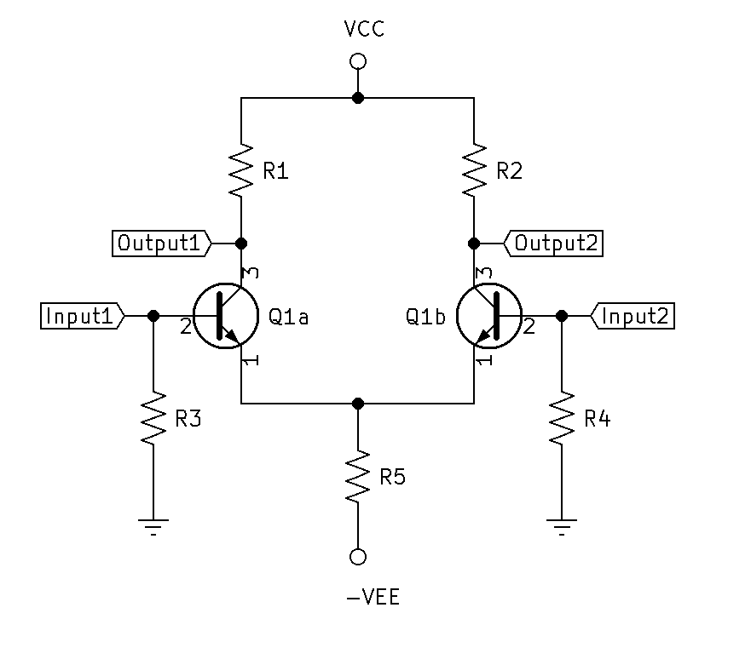A Differential Amplifier is an amplifier that produces outputs that are a function of the differnece between two inputs.
* Transistors are Beta matched.
* RCs are equal, (R1=R2)
* RBs are equal, (R3=R4)
* IR5 is equal to $2×IE$.
* Single-Ended Differential Input: The Diff-Amp is operated with one input grounded and signal voltage is applied to the other input.
  + 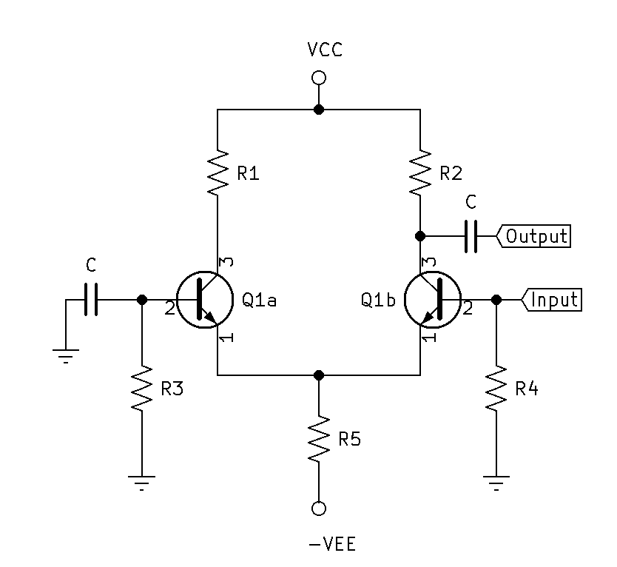Below is an example of Single-Ended Differential Input Inverting Amplifier.
  + 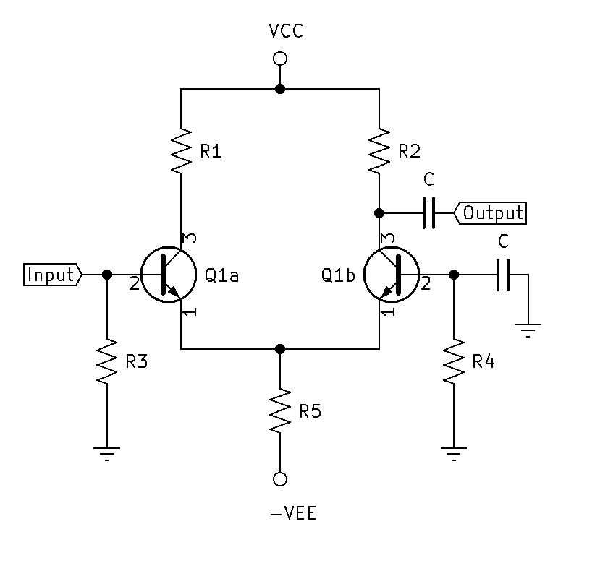Below is an example of Single-Ended Differential Input Non-Inverting Amplifier.
* 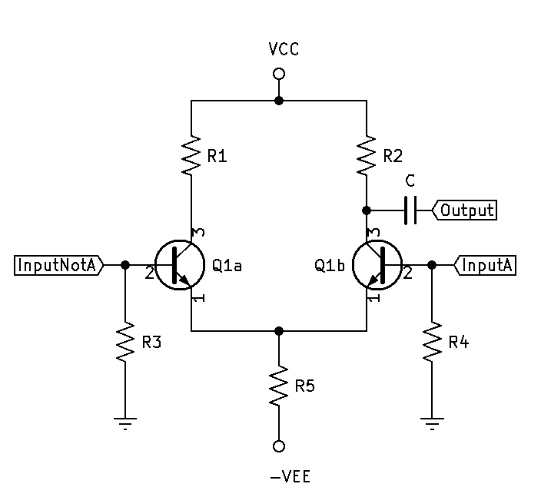Double-Ended Differential Inputs: Two 180 $°$ out of phase signals with the same amplitude and frequency are applied to the inputs. The gain resultant is $2×∆v$.
* 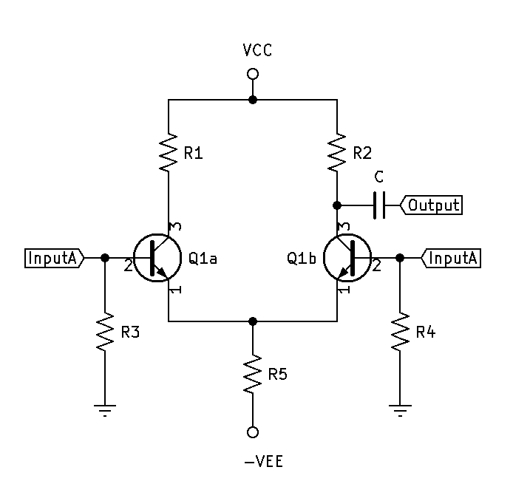Common-Mode: Two in-phase signals with the same amplitude and frequency are applied to the inputs. The gain resultant is $∆v≈0$.
* CMRR (Common-Mode Rejection Ration):The measure of an amplifers ability to reject Common-Mode signals.

${CMRR}_{dB}=20Log(\frac{∆vcm}{∆vdiff})$

